REPORT
on
SKILL ENHANCEMENT COURSE – I (Course Code: V23CSSE01)
B.TECH III Semester (2023 - 2027 Batch)
Academic Year: 2024-25



SRI VASAVI ENGINEERING COLLEGE (Autonomous)
Pedatadepalli, Tadepalligudem - 534101
Department of Computer Science & Engineering (Accredited by NBA)



SRI VASAVI ENGINEERING COLLEGE (Autonomous)
PEDATADEPALLI, TADEPALLIGUDEM.

This is to certify Mr./Ms. _______________________ bearing Roll No. ____________of CSE Branch of III Semester submitted the Report on ________________________as a part of SKILL ENHANCEMENT COURSE - I(Course Code: V23CSSE01)during the academic year 2024-25.

Faculty In charge Head of the Department

Examiner1 Examiner2

INDEX

S.No. | Name of the Topic |  | Page No's  (From-to)
 | Introduction to Python
 | List of Experiments
 | PROJECT
 |  | Abstract
 |  | Objectives of the project
 |  | Software and Hardware Requirements
 |  | Screenshots of the Project
 |  | Conclusion

1. Introduction to Python Programming

What is Python?
Python is a high-level, interpreted programming language, renowned for its simplicity and readability. Developed by Guido van Rossum and released in 1991, Python has gained immense popularity due to its versatility, ease of use, and wide range of applications. It supports multiple programming paradigms, including procedural, object-oriented, and functional programming.
Python is widely used across various fields such as web development, data science, artificial intelligence, automation, and more. One of its key advantages is the emphasis on readability, allowing developers to write clean, understandable code. Python also offers a vast standard library and an active, supportive community, making it highly adaptable for both small and large-scale projects.

Key Features of Python:
- Simple and Easy to Learn: Python’s syntax is clean and beginner-friendly, which makes it ideal for new programmers.
- Interpreted Language: Python code is executed line by line, which facilitates debugging and testing during development.
- Cross-Platform Compatibility: Python runs on multiple operating systems such as Windows, macOS, and Linux, providing cross-platform support.
- Extensive Standard Library: Python includes numerous modules and packages that cover areas such as web development, data manipulation, networking, and more.
- Large Community Support: Python has a strong, ever-growing community that provides continuous resources and support, from libraries to forums.

History of Python
Python was conceived in the late 1980s by Guido van Rossum as a successor to the ABC programming language, with the goal of creating a more powerful, yet easy-to-use language. The first version, Python 0.9.0, was released in 1991, and it included core features like exception handling, functions, and essential data types.
The language evolved significantly with the release of Python 2.0 in 2000, introducing features like list comprehensions and a garbage collection system. However, the most significant update came with Python 3.0 in 2008, which brought improvements to language consistency and eliminated many design flaws of earlier versions. Although Python 3 was not backward-compatible with Python 2, it has become the standard version, with most modern applications being developed in Python 3.
Python's growth has accelerated in recent years due to its role in cutting-edge fields like machine learning, data analysis, and AI, making it one of the most influential programming languages globally.

Why Choose Python?
Python’s simplicity, coupled with its powerful features and flexibility, makes it a preferred language for both beginners and experienced developers. It is often used for rapid application development because of its clear syntax, which reduces the development time and effort required. Furthermore, Python’s extensive libraries, frameworks, and active community make it a valuable tool in tackling modern-day programming challenges.
In summary, Python’s broad applicability, combined with its focus on readability and ease of use, has made it one of the most widely used and respected programming languages in the world.

Basic Concepts of Python :

Identifiers:
Identifiers are names used to identify variables, functions, classes, or objects. They must start with a letter (A-Z, a-z) or underscore _, followed by letters, digits (0-9), or underscores.
my_variable = 10
_myVar = "Python"
Identifiers cannot use reserved keywords and are case-sensitive.

Keywords:
Keywords are reserved words that have special meanings in Python and cannot be used as identifiers.
if, for, while, return, True, False, None
Python has a set of predefined keywords, like if, while, and True.

Statements and Expressions:
- Statements are instructions that perform an action.
- Expressions are combinations of values and operators that produce a result.
x = 5# Statement
y = x + 3# Expression
In the example, x = 5 is a statement, and y = x + 3 is an expression

Variables:
A variable holds data, and Python automatically assigns the data type based on the value assigned to the variable.
age = 21
name = "Siva"
No need to declare the variable type explicitly in Python.

Operators:
Operators perform operations on variables and values. Python has various types of operators like arithmetic, comparison, logical, etc.
a = 5 + 3# Arithmetic
b = a >2# Comparison
The operator types include arithmetic (+, -), comparison (==, >, <), and logical (and, or).

Data Types:
Python supports several built-in data types such as integers, floats, strings, lists, tuples, dictionaries, and sets.
num = 10# Integer
pi = 3.14# Float
Each variable's data type is determined based on the assigned value.

Indentation:
Python uses indentation to define blocks of code. It replaces the need for braces or brackets used in other languages.
ifTrue:
print("Indented block")
Consistent indentation is critical, and incorrect indentation leads to errors.

Comments:
Comments are non-executable lines in the code, used for adding notes or explanations.
# This is a single-line comment
Python ignores comments during execution.
Type Conversions:
Type conversion functions convert one data type to another, like int(), float(), str().
num = int("10") # String to integer
pi_str = str(3.14) # Float to string
They are used to change data types when needed, like converting input strings to numbers.

Looping Statements:
Looping statements allow code to be executed repeatedly based on a condition or a sequence.

for Loop:
The for loop is used to iterate over a sequence (like a list, tuple, or string).
for i in range(5):
print(i)
The loop runs for each item in the sequence, and in this case, it iterates from 0 to 4 using range().

While Loop:
The while loop repeats as long as a condition is True.
i = 1
while i <= 5:
print(i)
i += 1
This loop runs while the condition (i <= 5) is true, and stops when it becomes false.

Conditional Statements:
Conditional statements allow a program to make decisions based on conditions and execute different blocks of code accordingly.

If Statement:
The if statement is used to check a condition and execute a block of code if the condition is true.
x = 10
if x > 5:
print("x is greater than 5")
If the condition is true, the indented code block is executed.

if-else Statement:
The if-else statement adds an alternative block of code to execute if the condition is false.
x = 3
if x > 5:
print("x is greater than 5")
else:
print("x is not greater than 5")
The else block is executed if the if condition is false.

elif (Else-If) Statement:
The elif statement checks multiple conditions. If the first condition is false, the program checks the next condition.
x = 5
if x > 5:
print("x is greater than 5")
elif x == 5:
print("x is equal to 5")
else:
print("x is less than 5")
This allows multiple conditions to be checked in sequence.

Jumping Statements:
Jump statements are used to alter the normal flow of execution by skipping or exiting from loops or functions.

break Statement:
The break statement is used to exit a loop prematurely.
for i in range(10):
if i == 5:
break # Exits loop when i is 5
print(i)
The loop stops as soon as the break statement is encountered.

continue Statement:
The continue statement skips the current iteration and proceeds with the next one.
for i in range(5):
if i == 3:
continue # Skips printing when i is 3
print(i)
The loop continues but skips the iteration where i equals 3.

pass Statement:
The pass statement is a placeholder that does nothing but allows syntactically empty blocks.
if True:
pass # Does nothing
It is often used for code stubs or when defining functions or classes that will be implemented later.

Functions:
Functions are blocks of reusable code that perform specific tasks. They help in modularizing and organizing code, making it easier to read and maintain.

Function Definition and Calling the Function:
Functions are defined using the def keyword followed by the function name, parameters, and the block of code to be executed.
def add(a, b):
return a + b
result = add(5, 3) # Calling the function
You call a function by specifying its name followed by parentheses and any required arguments.

Scope and Lifetime of Variables:
The scope of a variable defines where it can be accessed, and its lifetime refers to how long it exists during execution. Variables inside a function are local and only accessible within that function.
def example():
x = 10 # Local variable
print(x)

example()
# print(x) # Error, as x is out of scope
Variables defined outside of functions have global scope and can be accessed anywhere in the code.

Default Parameters:
You can assign default values to parameters in a function. If the caller does not provide a value, the default is used.
def greet(name="Guest"):
print(f"Hello, {name}!")
greet() # Output: Hello, Guest!
greet("Siva") # Output: Hello, Siva!
Default parameters provide flexibility when calling functions, reducing the need to supply arguments in every call.

Keyword Arguments:
When calling a function, you can use keyword arguments to specify parameter values by name, making the order of arguments flexible.
def describe(name, age):
print(f"Name: {name}, Age: {age}")

describe(age=21, name="Siva") # Order of arguments doesn't matter
Keyword arguments improve code readability and allow for more flexible function calls.

Strings:
Strings in Python are sequences of characters used to represent text. They can be created using single, double, or triple quotes.
my_string = "Hello, World!" # Creating a string
Strings are immutable, meaning once created, their contents cannot be changed.

Lists:
Lists in Python are ordered, mutable collections of items. They can hold elements of different data types such as integers, strings, or even other lists.
my_list = [1, 2, 3, 4, 5] # Creating a list
Lists are versatile and allow modifications like adding, removing, or updating elements.

Dictionaries:
Dictionaries in Python are unordered collections of key-value pairs. They allow you to store data in a way that associates unique keys with values.
my_dict = {"name": "Siva", "age": 21} # Creating a dictionary
Dictionaries are mutable, meaning you can modify them after creation.

Tuples:
Tuples are immutable, ordered collections of items in Python. They can hold elements of different data types and are defined using parentheses ().
my_tuple = (1, 2, 3, 4, 5) # Creating a tuple
Once created, the contents of a tuple cannot be changed, making them suitable for fixed data collections.

Sets:
Sets are unordered collections of unique items. They are defined using curly braces {} or the set() function.
my_set = {1, 2, 3, 4} # Creating a set
empty_set = set() # Creating an empty set
Sets automatically remove duplicate entries and do not maintain order.

Creating and Reading Text Data:
You can create and read text data using the open() function along with modes like 'r' for reading and 'w' for writing.
with open('example.txt', 'w') as file: # Creating and writing to a text file
file.write("Hello, World!") # Writing text data
Reading is done using the same open() function with the appropriate mode.

File Methods to Read and Write Data:
Python provides various file methods, such as read(), readline(), readlines(), write(), and writelines().
with open('example.txt', 'r') as file:
lines = file.readlines() # Reading all lines into a list
These methods help manipulate file content easily.

Reading and Writing Binary Files:
Binary files are handled using the 'rb' and 'wb' modes for reading and writing.
with open('image.jpg', 'rb') as file: # Reading a binary file
data = file.read()
Binary files require specific handling as they store data in non-text formats.
Reading and Writing CSV Files:
CSV files can be handled using the csv module, which provides functionality to read and write data in a comma-separated format.
import csv

with open('data.csv', 'r') as file: # Reading a CSV file
reader = csv.reader(file)
for row in reader:
print(row)
The csv module simplifies CSV file operations.

Python os and os.path Modules:
The os and os.path modules provide functions to interact with the operating system, including file and directory manipulation.
import os

current_directory = os.getcwd() # Getting the current working directory
These modules offer utility functions for managing files and directories.

Object-Oriented Programming:
Object-Oriented Programming (OOP) is a programming paradigm based on the concept of "objects," which can contain data and methods.
class Dog: # Creating a class
def bark(self):
print("Woof!")
OOP allows for more organized and reusable code.

Classes and Objects:
Classes are blueprints for creating objects, encapsulating data and behaviors.
class Car: # Defining a class
def __init__(self, model): # Constructor method
self.model = model # Instance variable

my_car = Car("Toyota") # Creating an object
Objects are instances of classes that hold data and methods.

Encapsulation:
Encapsulation is the practice of restricting access to certain components of an object, typically using private variables.
class Counter:
def __init__(self):
self.__count = 0 # Private variable

def increment(self):
self.__count += 1
Encapsulation enhances data hiding and protects the integrity of the object's data.

Inheritance:
Inheritance allows a class to inherit properties and methods from another class.
class Animal: # Parent class
def speak(self):
print("Animal speaks")

class Dog(Animal): # Child class
def bark(self):
print("Woof!")
Child classes can override or extend functionalities of parent classes.

Polymorphism:
Polymorphism allows methods to do different things based on the object it is acting upon, often through method overriding.
class Cat(Animal): # Child class
def speak(self):
print("Meow!")

def animal_sound(animal):
animal.speak() # Calls the speak method based on the animal type
Polymorphism promotes flexibility and reusability in code.

NumPy with Python:
NumPy is a powerful library for numerical computing in Python, providing support for arrays, matrices, and a collection of mathematical functions.
import numpy as np

# Creating a NumPy array
array = np.array([1, 2, 3, 4])
NumPy enhances performance and efficiency for mathematical computations on large datasets.

Pandas:
Pandas is a data manipulation and analysis library for Python, providing data structures like Series and DataFrames to handle structured data.
import pandas as pd

# Creating a DataFrame
data = {'Name': ['Siva', 'John'], 'Age': [21, 25]}
df = pd.DataFrame(data)
Pandas makes it easy to clean, manipulate, and analyze data in various formats.

2. LIST OF EXPERIMENTS

UNIT - I

1. Develop a program to find the largest element among three Numbers.
def find_largest(num1, num2, num3):
return max(num1, num2, num3)

num1 = int(input("Enter first number: "))
num2 = int(input("Enter second number: "))
num3 = int(input("Enter third number: "))

largest = find_largest(num1, num2, num3)
print("The largest number is:", largest)
Output:
Enter first number: 12
Enter second number: 25
Enter third number: 7
The largest number is: 25

2. Develop a Program to display all prime numbers within an interval.
def display_primes(start, end):
primes = []
for num in range(start, end + 1):
if num > 1:
for i in range(2, int(num ** 0.5) + 1):
if num % i == 0:
break
else:
primes.append(num)
return primes

start = int(input("Enter the starting number: "))
end = int(input("Enter the ending number: "))

prime_numbers = display_primes(start, end)
print("Prime numbers between", start, "and", end, "are:", prime_numbers)

Output:
Enter the starting number: 10
Enter the ending number: 50
Prime numbers between 10 and 50 are: [11, 13, 17, 19, 23, 29, 31, 37, 41, 43, 47]

3. Develop a program to swap two numbers without using a temporary variable.
def swap_numbers(a, b):
a = a + b
b = a - b
a = a - b
return a, b

num1 = int(input("Enter first number: "))
num2 = int(input("Enter second number: "))

num1, num2 = swap_numbers(num1, num2)
print("After swapping: First number =", num1, "and Second number =", num2)
Output:
Enter first number: 5
Enter second number: 10
After swapping: First number = 10 and Second number = 5

4. Demonstrate the following Operators in Python with suitable examples.

# Arithmetic Operators
a = 10
b = 20
print("Arithmetic Operators:")
print("Addition:", a + b)
print("Subtraction:", a - b)
print("Multiplication:", a * b)
print("Division:", a / b)
print("Modulus:", a % b)

# Relational Operators
print("\nRelational Operators:")
print("Is a greater than b?", a > b)
print("Is a equal to b?", a == b)

# Assignment Operators
c = 5
print("\nAssignment Operators:")
c += 2
print("c after adding 2:", c)

# Logical Operators
print("\nLogical Operators:")
print("True and False:", True and False)
print("True or False:", True or False)

# Bitwise Operators
print("\nBitwise Operators:")
print("AND:", a & b)
print("OR:", a | b)

# Ternary Operator
max_value = a if a > b else b
print("\nTernary Operator: Max value is", max_value)

# Membership Operators
list_a = [1, 2, 3, 4, 5]
print("\nMembership Operators:")
print("Is 3 in list_a?", 3 in list_a)

# Identity Operators
print("\nIdentity Operators:")
print("Is a identical to b?", a is b)
Output:
Arithmetic Operators:
Addition: 30
Subtraction: -10
Multiplication: 200
Division: 0.5
Modulus: 10

Relational Operators:
Is a greater than b? False
Is a equal to b? False

Assignment Operators:
c after adding 2: 7

Logical Operators:
True and False: False
True or False: True

Bitwise Operators:
AND: 0
OR: 30

Ternary Operator: Max value is 20

Membership Operators:
Is 3 in list_a? True

Identity Operators:
Is a identical to b? False

5. Develop a program to add and multiply complex numbers.
def add_multiply_complex(c1, c2):
addition = c1 + c2
multiplication = c1 * c2
return addition, multiplication
real1 = float(input("Enter real part of first complex number: "))
imag1 = float(input("Enter imaginary part of first complex number: "))
real2 = float(input("Enter real part of second complex number: "))
imag2 = float(input("Enter imaginary part of second complex number: "))

complex1 = complex(real1, imag1)
complex2 = complex(real2, imag2)

sum_result, product_result = add_multiply_complex(complex1, complex2)
print("Sum:", sum_result)
print("Product:", product_result)
Output:
Enter real part of first complex number: 2
Enter imaginary part of first complex number: 3
Enter real part of second complex number: 4
Enter imaginary part of second complex number: 5
Sum: (6+8j)
Product: (-7+22j)

6. Develop a program to print multiplication table of a given number.
def print_multiplication_table(num):
print(f"Multiplication table of {num}:")
for i in range(1, 11):
print(f"{num} x {i} = {num * i}")

number = int(input("Enter a number to print its multiplication table: "))
print_multiplication_table(number)
Output:
Enter a number to print its multiplication table: 7
Multiplication table of 7:
7 x 1 = 7
7 x 2 = 14
7 x 3 = 21
7 x 4 = 28
7 x 5 = 35
7 x 6 = 42
7 x 7 = 49
7 x 8 = 56
7 x 9 = 63
7 x 10 = 70

UNIT - II

1. Develop a program to define a function using default arguments.
def greet(name, greeting="Hello"):
return f"{greeting}, {name}!"
name_input = input("Enter your name: ")

message = greet(name_input)
print(message)

custom_greeting = input("Enter a custom greeting: ")
message_custom = greet(name_input, custom_greeting)
print(message_custom)
Output:
Enter your name: Alice
Enter a custom greeting: Hi
Copy code
Hello, Alice!
Hi, Alice!

2. Develop a program to find the length of the string without using any library functions.
def string_length(s):
count = 0
for char in s:
count += 1
return count

user_string = input("Enter a string: ")

length = string_length(user_string)
print("Length of the string is:", length)
Output:
Enter a string: Hello, World!
Length of the string is: 13

3. Develop a program to check if the substring is present in a given string or not.
def check_substring(string, substring):
return substring in string

main_string = input("Enter the main string: ")
sub_string = input("Enter the substring to check: ")

if check_substring(main_string, sub_string):
print("Substring is present in the main string.")
else:
print("Substring is not present in the main string.")
Output:
Enter the main string: Python programming is fun.
Enter the substring to check: fun
Substring is present in the main string.

4. Develop a program to perform the given operations on a list: i. addition ii. Insertion iii. slicing
def list_operations(lst):
# Addition
lst.append(5)

# Insertion
lst.insert(2, 10) # Inserting 10 at index 2

# Slicing
sliced_list = lst[1:4] # Slicing elements from index 1 to 3

return lst, sliced_list
user_list = [int(x) for x in input("Enter a list of numbers separated by space: ").split()]

modified_list, sliced = list_operations(user_list)
print("Modified List:", modified_list)
print("Sliced List:", sliced)
Output:
Enter a list of numbers separated by space: 1 2 3 4
Modified List: [1, 2, 10, 3, 4, 5]
Sliced List: [2, 10, 3]

5. Develop a program to perform any 5 built-in functions by taking any list.
# Function to demonstrate built-in list functions
def built_in_list_functions(lst):
# Count occurrences of an element
count_of_2 = lst.count(2)

# Sort the list
sorted_list = sorted(lst)

# Reverse the list
lst.reverse()

# Pop the last element
popped_element = lst.pop()

# Extend the list
lst.extend([7, 8])

return count_of_2, sorted_list, lst, popped_element

# Input from user
user_list = [int(x) for x in input("Enter a list of numbers separated by space: ").split()]

# Performing built-in functions
count_2, sorted_list, modified_list, popped = built_in_list_functions(user_list)
print("Count of 2:", count_2)
print("Sorted List:", sorted_list)
print("Modified List after pop and extend:", modified_list)
print("Popped Element:", popped)
Output:
Enter a list of numbers separated by space: 1 2 2 3 4
Count of 2: 2
Sorted List: [1, 2, 2, 3, 4]
Modified List after pop and extend: [4, 3, 2, 2, 7, 8]
Popped Element: 1

UNIT - III

1. Develop a program to create tuples (name, age, address, college) for at least two members and concatenate the tuples and print the concatenated tuples.
member1 = ("Alice", 21, "123 Main St", "ABC College")
member2 = ("Bob", 22, "456 Oak Ave", "XYZ College")
concatenated = member1 + member2
print("Concatenated Tuple:", concatenated)
Output:
Concatenated Tuple: ('Alice', 21, '123 Main St', 'ABC College', 'Bob', 22, '456 Oak Ave', 'XYZ College')

2. Develop a program to count the number of vowels in a string (No control flow allowed).

def count_vowels(string):
vowels = "aeiouAEIOU"
return sum(char in vowels for char in string)
user_string = input("Enter a string: ")
vowel_count = count_vowels(user_string)
print("Number of vowels in the string:", vowel_count)
Output:
Enter a string: OpenAI is awesome!
Number of vowels in the string: 6

3. Develop a program to check if a given key exists in a dictionary or not.
def check_key_existence(dictionary, key):
return key in dictionary

my_dict = {'a': 1, 'b': 2, 'c': 3}
key_to_check = input("Enter a key to check: ")

if check_key_existence(my_dict, key_to_check):
print(f"Key '{key_to_check}' exists in the dictionary.")
else:
print(f"Key '{key_to_check}' does not exist in the dictionary.")

Output:
Enter a key to check: b
Key 'b' exists in the dictionary.

4. Develop a program to add a new key-value pair to an existing dictionary.
# Function to add key-value pair to a dictionary
def add_key_value(dictionary, key, value):
dictionary[key] = value
return dictionary

# Input from user
my_dict = {'a': 1, 'b': 2, 'c': 3}
new_key = input("Enter new key: ")
new_value = input("Enter value for the new key: ")

# Adding the new key-value pair
updated_dict = add_key_value(my_dict, new_key, new_value)
print("Updated Dictionary:", updated_dict)
Output:
Enter new key: d
Enter value for the new key: 4
Updated Dictionary: {'a': 1, 'b': 2, 'c': 3, 'd': 4}

5. Develop a program to sum all the items in a given dictionary.
# Function to sum values in a dictionary
def sum_dict_values(dictionary):
return sum(dictionary.values())

# Input from user
my_dict = {'a': 10, 'b': 20, 'c': 30}

# Calculating sum
total_sum = sum_dict_values(my_dict)
print("Sum of all items in the dictionary:", total_sum)
Output:
Sum of all items in the dictionary: 60
UNIT - IV

1. Develop a program to sort words in a file and put them in another file. The output file should have only lower-case words, so any upper-case words from source must be lowered.
# Function to sort words from a file and write to another file
def sort_words_in_file(input_file, output_file):
with open(input_file, 'r') as file:
words = file.read().split()
words = [word.lower() for word in words] # Lower casing words
words.sort() # Sorting words

with open(output_file, 'w') as file:
for word in words:
file.write(word + "\n")

# Example usage
input_file_name = 'input.txt'
output_file_name = 'output.txt'
sort_words_in_file(input_file_name, output_file_name)
print(f"Words sorted and written to {output_file_name}.")
Assuming input.txt contains:
Hello World
This is a Test
Output File (output.txt):
a
hello
is
test
this
world

2. Develop a Python program to print each line of a file in reverse order.
# Function to print each line of a file in reverse order
def print_lines_reverse(file_name):
with open(file_name, 'r') as file:
lines = file.readlines()
for line in reversed(lines):
print(line.strip())

# Example usage
input_file_name = 'input.txt'
print("Lines in reverse order:")
print_lines_reverse(input_file_name)
Assuming input.txt contains:
Line 1
Line 2
Line 3
Output:
Lines in reverse order:
Line 3
Line 2
Line 1

3.Develop a Python program to compute the number of characters, words, and lines in a file.
# Function to compute characters, words, and lines in a file
def compute_file_metrics(file_name):
with open(file_name, 'r') as file:
content = file.read()
num_lines = content.count('\n') + 1
num_words = len(content.split())
num_chars = len(content)

return num_lines, num_words, num_chars

# Example usage
input_file_name = 'input.txt'
lines, words, chars = compute_file_metrics(input_file_name)
print(f"Lines: {lines}, Words: {words}, Characters: {chars}")
Assuming input.txt contains:
This is a test file.
It has several lines.
Output:
Lines: 2, Words: 9, Characters: 42

4. Develop a program to create, display, append, insert, and reverse the order of the items in the array.
# Program to create, display, append, insert, and reverse items in an array
def array_operations():
# Create an array from user input
array = list(map(int, input("Enter numbers separated by spaces: ").split()))

# Display original array
print("Original array:", array)

# Append an item
item_to_append = int(input("Enter a number to append: "))
array.append(item_to_append)
print("Array after appending:", array)

# Insert an item at a specified index
index_to_insert = int(input("Enter the index to insert at: "))
item_to_insert = int(input("Enter a number to insert: "))
array.insert(index_to_insert, item_to_insert)
print("Array after inserting:", array)

# Reverse the array
array.reverse()
print("Reversed array:", array)

array_operations()
Output:
Enter numbers separated by spaces: 1 2 3 4 5
Enter a number to append: 6
Enter the index to insert at: 2
Enter a number to insert: 99
Original array: [1, 2, 3, 4, 5]
Array after appending: [1, 2, 3, 4, 5, 6]
Array after inserting: [1, 2, 99, 3, 4, 5, 6]
Reversed array: [6, 5, 4, 3, 99, 2, 1]

5. Develop a program to add, transpose, and multiply two matrices.
# Program to add, transpose, and multiply two matrices
def matrix_operations():
# Input for matrix A
rows_A = int(input("Enter number of rows for Matrix A: "))
cols_A = int(input("Enter number of columns for Matrix A: "))
A = []
print("Enter the elements of Matrix A:")
for i in range(rows_A):
row = list(map(int, input().split()))
A.append(row)

# Input for matrix B
rows_B = int(input("Enter number of rows for Matrix B: "))
cols_B = int(input("Enter number of columns for Matrix B: "))
B = []
print("Enter the elements of Matrix B:")
for i in range(rows_B):
row = list(map(int, input().split()))
B.append(row)

# Matrix addition
add_result = [[A[i][j] + B[i][j] for j in range(cols_A)] for i in range(rows_A)]
print("Matrix A + B:")
for row in add_result:
print(row)
# Matrix transpose
transpose_A = [[A[j][i] for j in range(rows_A)] for i in range(cols_A)]
print("\nTranspose of Matrix A:")
for row in transpose_A:
print(row)

# Matrix multiplication
multiply_result = [[sum(A[i][k] * B[k][j] for k in range(cols_A)) for j in range(cols_B)] for i in range(rows_A)]
print("\nMatrix A * B:")
for row in multiply_result:
print(row)

matrix_operations()
Output:
Enter number of rows for Matrix A: 2
Enter number of columns for Matrix A: 3
Enter the elements of Matrix A:
1 2 3
4 5 6
Enter number of rows for Matrix B: 3
Enter number of columns for Matrix B: 3
Enter the elements of Matrix B:
7 8 9
10 11 12
13 14 15

Matrix A + B:
[8, 10, 12]

Transpose of Matrix A:
[1, 4]
[2, 5]
[3, 6]

Matrix A * B:
[74, 82, 90]
[106, 122, 138]

6. Develop a Python program to create a class that represents a shape. Include methods to calculate its area and perimeter. Implement subclasses for different shapes like circle, triangle, and square.
import math

# Base class
class Shape:
def area(self):
pass

def perimeter(self):
pass

# Subclass for Circle
class Circle(Shape):
def __init__(self, radius):
self.radius = radius

def area(self):
return math.pi * self.radius ** 2

def perimeter(self):
return 2 * math.pi * self.radius

# Subclass for Triangle
class Triangle(Shape):
def __init__(self, base, height, side1, side2):
self.base = base
self.height = height
self.side1 = side1
self.side2 = side2

def area(self):
return 0.5 * self.base * self.height

def perimeter(self):
return self.base + self.side1 + self.side2

# Subclass for Square
class Square(Shape):
def __init__(self, side):
self.side = side

def area(self):
return self.side ** 2

def perimeter(self):
return 4 * self.side

# Test the classes
def shape_operations():
radius = float(input("Enter the radius of the circle: "))
circle = Circle(radius)
print("Circle Area:", circle.area())
print("Circle Perimeter:", circle.perimeter())

base = float(input("Enter the base of the triangle: "))
height = float(input("Enter the height of the triangle: "))
side1 = float(input("Enter the length of side 1 of the triangle: "))
side2 = float(input("Enter the length of side 2 of the triangle: "))
triangle = Triangle(base, height, side1, side2)
print("\nTriangle Area:", triangle.area())
print("Triangle Perimeter:", triangle.perimeter())

side = float(input("Enter the side length of the square: "))
square = Square(side)
print("\nSquare Area:", square.area())
print("Square Perimeter:", square.perimeter())

shape_operations()
Output:
Enter the radius of the circle: 5
Enter the base of the triangle: 3
Enter the height of the triangle: 4
Enter the length of side 1 of the triangle: 3
Enter the length of side 2 of the triangle: 4
Enter the side length of the square: 4

Circle Area: 78.53981633974483
Circle Perimeter: 31.41592653589793

Triangle Area: 6.0
Triangle Perimeter: 10.0

Square Area: 16
Square Perimeter: 16

UNIT - V

1. Develop a Python program to check whether a JSON string contains a complex object or not.
import json

# Function to check for complex objects in JSON
def check_complex_object(json_string):
try:
data = json.loads(json_string)
if isinstance(data, dict):
return any(isinstance(value, (list, dict)) for value in data.values())
return False
except json.JSONDecodeError:
return False

# Test cases
def json_operations():
json_string1 = input("Enter JSON string 1: ")
json_string2 = input("Enter JSON string 2: ")

print("JSON 1 contains complex object:", check_complex_object(json_string1))
print("JSON 2 contains complex object:", check_complex_object(json_string2))

json_operations()
Output:
Enter JSON string 1: {"name": "Alice", "age": 30, "children": [{"name": "Bob"}]}
Enter JSON string 2: {"name": "Alice", "age": 30}

JSON 1 contains complex object: True
JSON 2 contains complex object: False

2. Demonstrate NumPy arrays creation using the array() function.
import numpy as np

# Creating a NumPy array using the array() function
def create_numpy_array():
array_elements = list(map(int, input("Enter numbers separated by spaces: ").split()))
array = np.array(array_elements)
print("NumPy Array:", array)

create_numpy_array()
Output:
Enter numbers separated by spaces: 1 2 3 4 5

NumPy Array: [1 2 3 4 5]

3. Demonstrate use of ndim, shape, size, dtype.
import numpy as np

# Function to demonstrate ndim, shape, size, dtype
def array_properties():
array_elements = list(map(int, input("Enter numbers separated by spaces: ").split()))
array = np.array(array_elements)

print("Array:", array)
print("Number of dimensions:", array.ndim)
print("Shape of array:", array.shape)
print("Size of array:", array.size)
print("Data type of array:", array.dtype)

array_properties()
Output:
Enter numbers separated by spaces: 1 2 3 4 5

Array: [1 2 3 4 5]
Number of dimensions: 1
Shape of array: (5,)
Size of array: 5
Data type of array: int64

4. Demonstrate basic slicing, integer and Boolean indexing.
import numpy as np

# Function to demonstrate slicing, integer indexing, and boolean indexing
def slicing_indexing():
array = np.array([1, 2, 3, 4, 5, 6, 7, 8, 9])
print("Original Array:", array)

# Basic slicing
sliced_array = array[2:5] # Slicing from index 2 to 4
print("Sliced Array (2:5):", sliced_array)

# Integer indexing
indices = [0, 2, 4]
indexed_array = array[indices]
print("Indexed Array (0, 2, 4):", indexed_array)

# Boolean indexing
boolean_array = array[array > 5]
print("Boolean Indexed Array (elements > 5):", boolean_array)

slicing_indexing()
Output:
Original Array: [1 2 3 4 5 6 7 8 9]
Sliced Array (2:5): [3 4 5]
Indexed Array (0, 2, 4): [1 3 5]
Boolean Indexed Array (elements > 5): [6 7 8 9]

5. Develop a Python program to find min, max, sum, cumulative sum of an array.
import numpy as np

# Function to find min, max, sum, cumulative sum of an array
def array_statistics():
array_elements = list(map(int, input("Enter numbers separated by spaces: ").split()))
array = np.array(array_elements)

print("Array:", array)
print("Minimum value:", np.min(array))
print("Maximum value:", np.max(array))
print("Sum of elements:", np.sum(array))
print("Cumulative sum:", np.cumsum(array))

array_statistics()
Output:
Enter numbers separated by spaces: 1 2 3 4 5

Array: [1 2 3 4 5]
Minimum value: 1
Maximum value: 5
Sum of elements: 15
Cumulative sum: [ 1 3 6 10 15]

6. Prepare a dictionary with at least five keys, and each key represents a value as a list where this list contains at least ten values, and convert this dictionary to a pandas DataFrame and explore the data.
import pandas as pd

# Function to convert dictionary to DataFrame and explore
def dictionary_to_dataframe():
data = {
'A': list(range(1, 11)),
'B': list(range(11, 21)),
'C': list(range(21, 31)),
'D': list(range(31, 41)),
'E': list(range(41, 51)),
}

# Create DataFrame
df = pd.DataFrame(data)
print("DataFrame:\n", df)

# Explore the DataFrame
print("\nHead of DataFrame:\n", df.head())
print("\nSelecting Column 'A':\n", df['A'])
print("\nSelecting Columns 'B' and 'C':\n", df[['B', 'C']])

dictionary_to_dataframe()

Output:
DataFrame:
A B C D E
0 1 11 21 31 41
1 2 12 22 32 42
2 3 13 23 33 43
3 4 14 24 34 44
4 5 15 25 35 45
5 6 16 26 36 46
6 7 17 27 37 47
7 8 18 28 38 48
8 9 19 29 39 49
9 10 20 30 40 50

Head of DataFrame:
A B C D E
0 1 11 21 31 41
1 2 12 22 32 42
2 3 13 23 33 43
3 4 14 24 34 44
4 5 15 25 35 45

Selecting Column 'A':
0 1
1 2
2 3
3 4
4 5
5 6
6 7
7 8
8 9
9 10
Name: A, dtype: int64

Selecting Columns 'B' and 'C':
B C
0 11 21
1 12 22
2 13 23
3 14 24
4 15 25
5 16 26
6 17 27
7 18 28
8 19 29
9 20 30

7. Select any two columns from the above DataFrame, and observe the change in one attribute with respect to the other attribute with scatter and plot operations in Matplotlib.
import pandas as pd
import matplotlib.pyplot as plt

# Function to select two columns and plot
def plot_data():
data = {
'A': list(range(1, 11)),
'B': list(range(11, 21)),
'C': list(range(21, 31)),
'D': list(range(31, 41)),
'E': list(range(41, 51)),
}

# Create DataFrame
df = pd.DataFrame(data)

# Plotting
plt.scatter(df['A'], df['B'])
plt.title('Scatter Plot of A vs B')
plt.xlabel('A')
plt.ylabel('B')
plt.show()

plot_data()

Output:
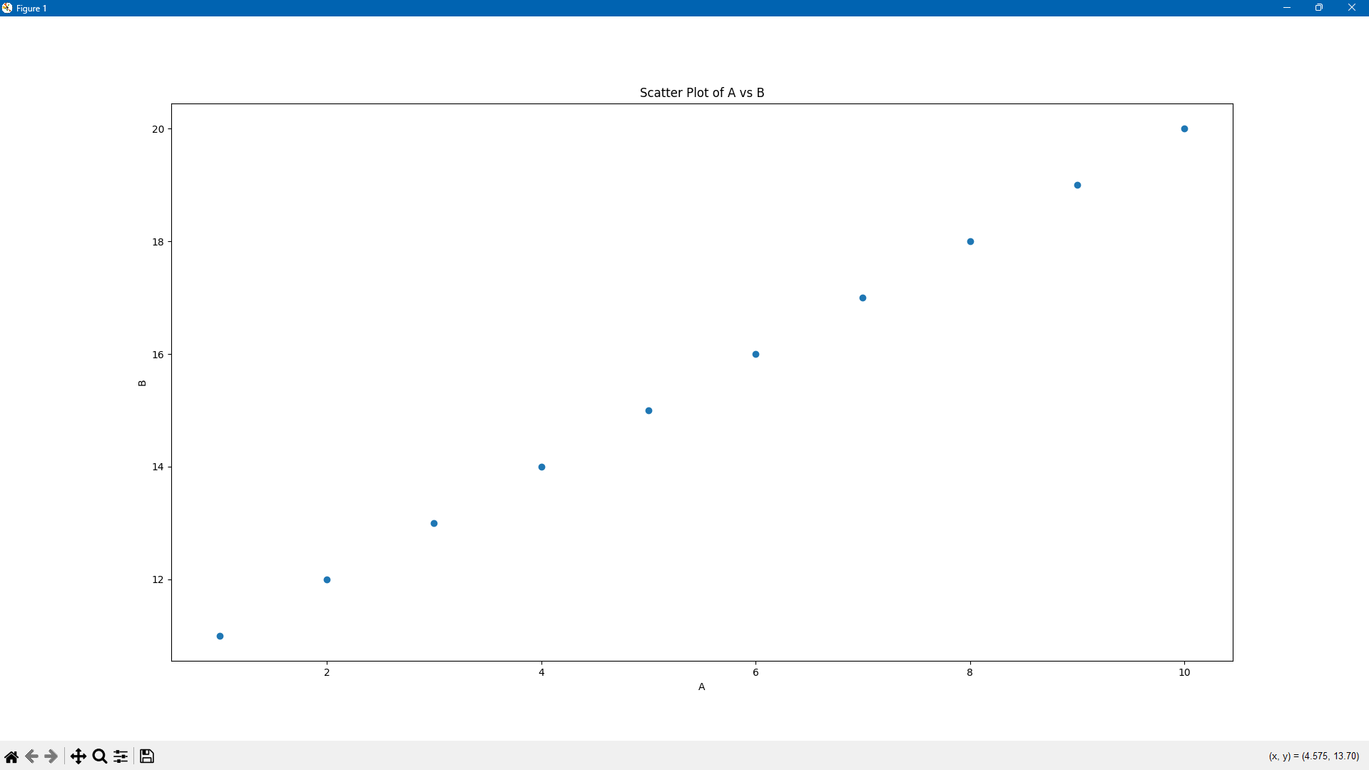

3. PROJECT

ABSTRACT:
The Explore Bus is an innovative, graphical interface-based application developed in Python, specifically designed to provide users with quick and comprehensive access to bus routes and detailed bus information. This system primarily serves to assist individuals in identifying buses that pass through their chosen village or stop. Through this user-friendly interface, users can input a village or stop name and instantly view all buses that serve the area, including specific details about each bus, such as the bus number, list of stops, driver’s name, and contact information. This design caters to a wide range of users, including college students, faculty, and community members who rely on public or college transit systems.
One of the distinctive features of this application is its integration with Google Maps, offering users a dynamic experience by allowing them to open bus routes in their default web browser. By simply clicking a button, users can view a live map showing the bus’s path, giving them a clear visual of the route and estimated travel directions. This feature proves especially useful in settings where bus routes are extensive, and users need to understand the geographic context of the journey.
To achieve a seamless user experience, the application utilizes real-time searching and auto-suggestions. As the user begins typing a village or stop name, the system provides a list of matching names based on available bus routes, thereby reducing errors and ensuring accuracy in searches. This feature is particularly valuable for large networks, where routes might cover several hundred villages and stops. Additionally, the interface displays error messages in case an invalid name is entered, guiding the user to retry with a correct entry.

OBJECTIVES OF THE PROJECT:
The Explore Bus System aims to create an accessible interface for easy bus route inquiries. Users can enter a village or bus stop name to instantly get bus information, minimizing traditional lookup methods. Integrated Google Maps links allow users to view routes directly, enhancing navigation for college campuses with extensive routes. The system provides quick, automated access to bus and driver details, reducing manual inquiries. It features a visually engaging, full-screen interface with rotating background images and user-friendly buttons. Built for cross-platform compatibility, it can be bundled as an executable, allowing easy distribution without Python installation requirements.

SOFTWARE AND HARDWARE REQUIREMENTS
Software Requirements:
- Python 3.8 or Higher: The application is built using Python, with essential libraries including Tkinter for the GUI, PIL for image handling, and webbrowser for external map links.
- Tkinter: Required to create the graphical interface.
- Pillow (PIL): For handling images, resizing, and background display.
- Webbrowser Module: To open Google Maps links directly from the application.
- Optional Software: PyInstaller can be used to compile the code into an executable, making it easy for non-programmers to access the application.
Hardware Requirements:
- Processor: Minimum dual-core processor with at least 1.8 GHz.
- Memory: 2GB RAM minimum.
- Storage: Approximately 100 MB, with extra space needed if using additional background images or expanding the bus data.
- Display: Full HD or higher resolution recommended for an optimal interface experience.

SCREENSHOTS OF THE PROJECT
1. Welcome Page(s): Welcome page is displayed by selecting a random image in a list of three images. “Begin Search” button will take the user to the village entering page and the “Exit” button will exit from the code.
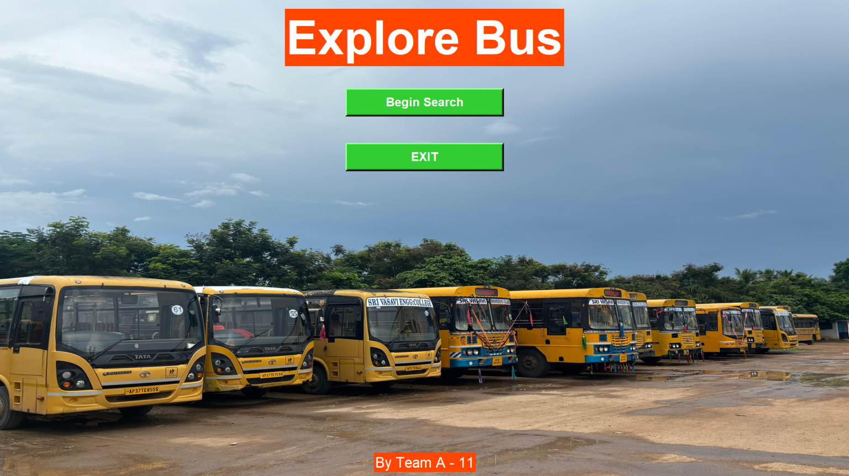
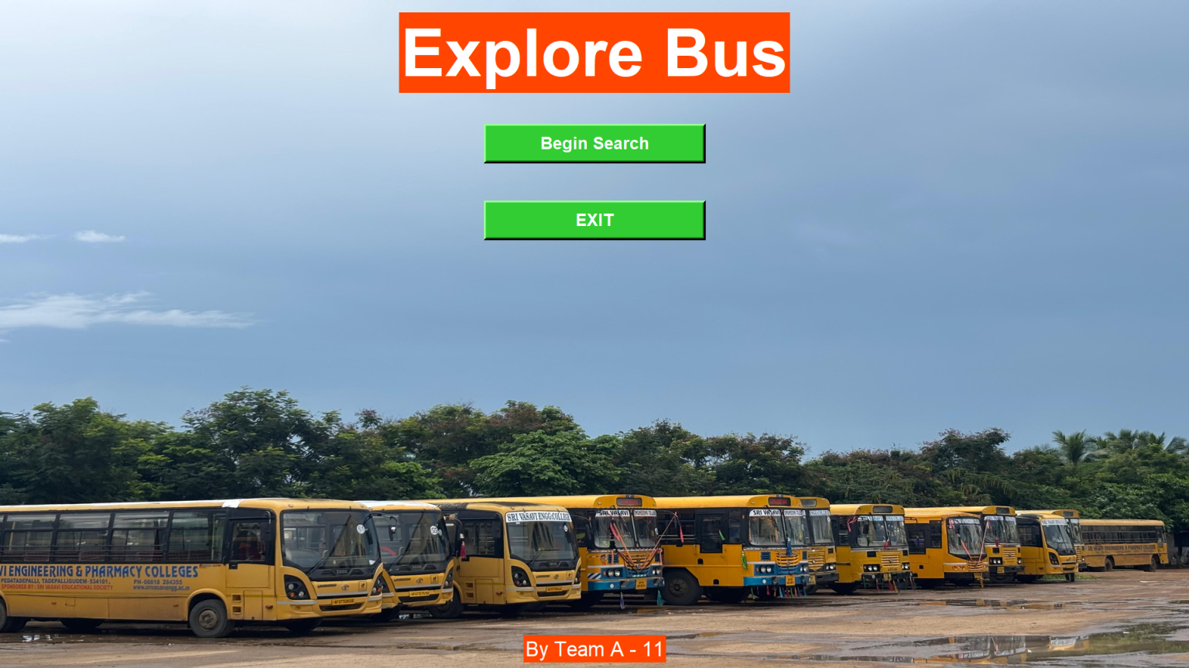

2. Input Village : The user have to give the village name to get the bus details of that particular village and autosuggestions will be displayed while entering the village name. After clicking “Enquire” button will take to the Results window and “Back” button will exit from the current page.
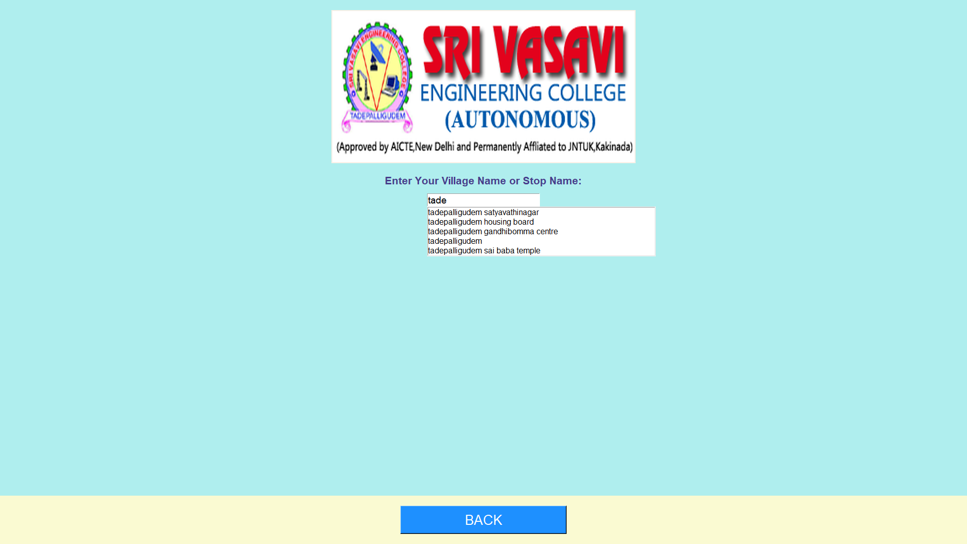
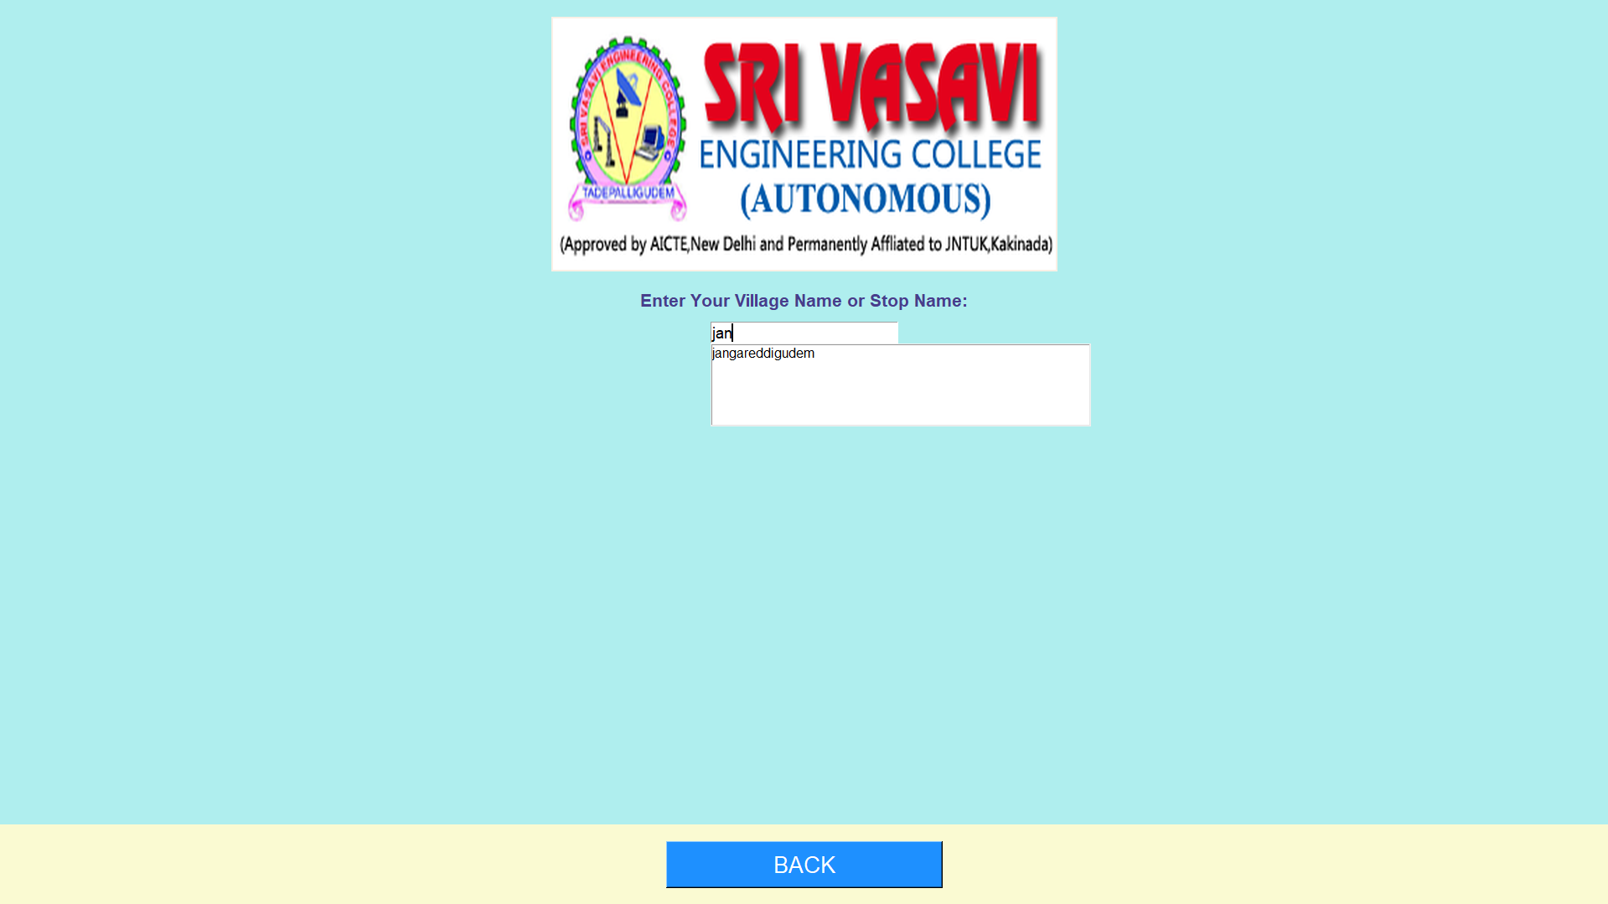
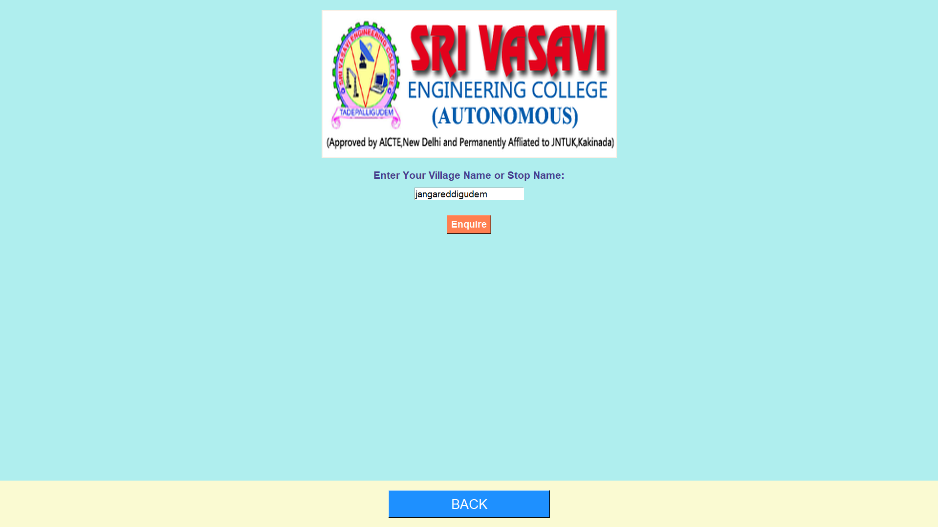

3. Error Message: Displaying the alert when an invalid village or stop name is entered, ensuring robust error handling.
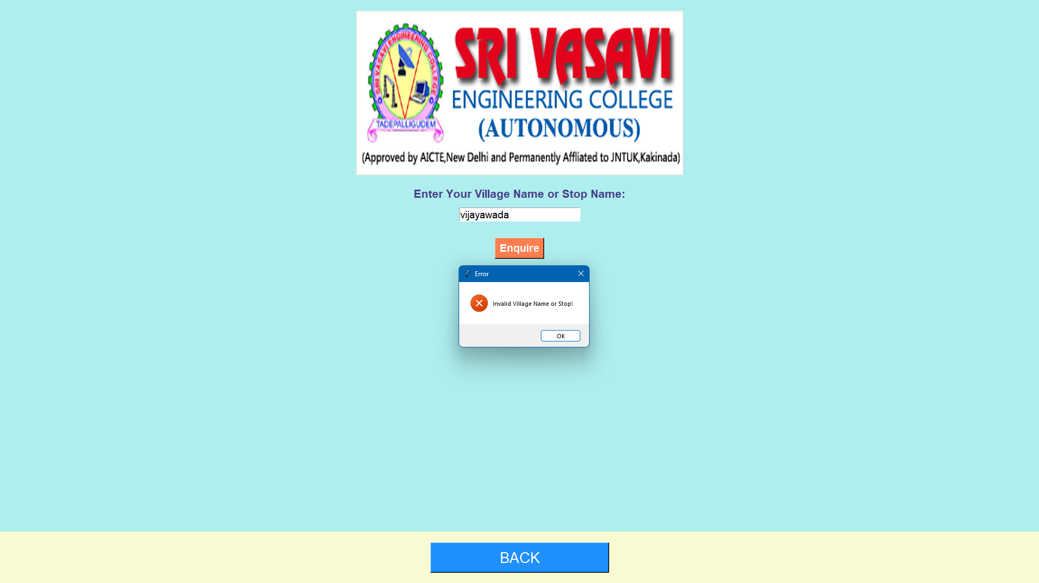
4. Search Results Window: Showing bus details such as bus number, stops, driver name, and contact, with an option to view the route on Google Maps and “Back” button will exit from the current page.
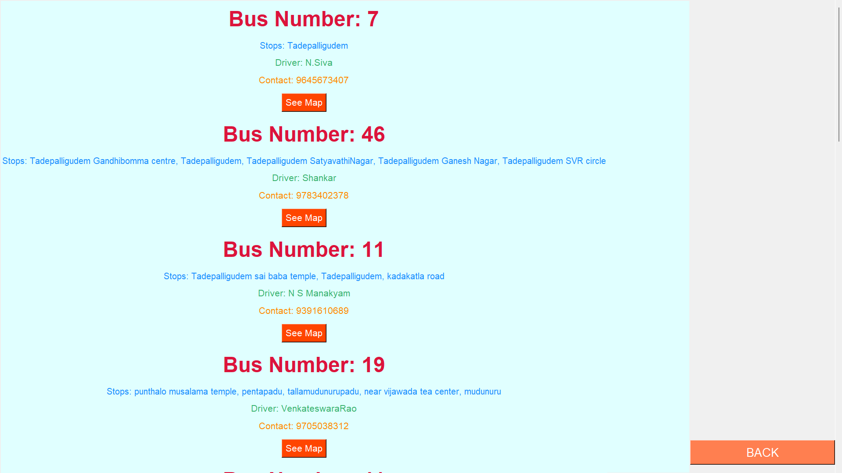
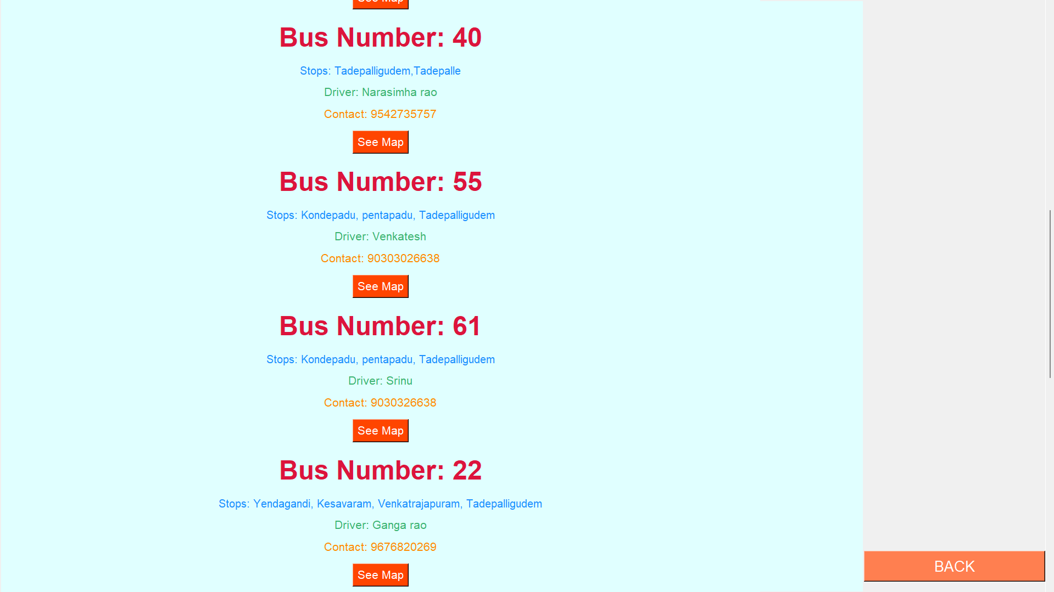

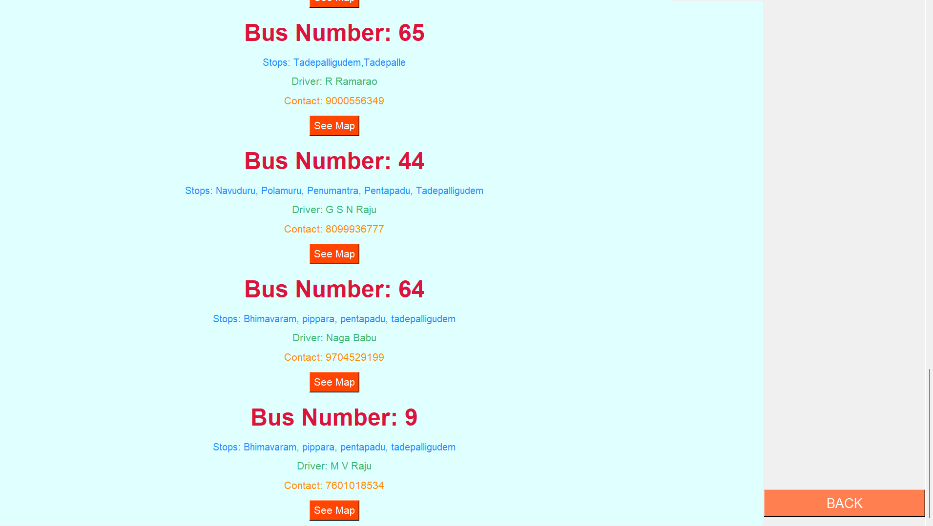

5. Map Integration: A Google Maps page will be displayed after clicking the “See Map” button, visualizing the bus route from the villages to the college.
Bus No. 11 :
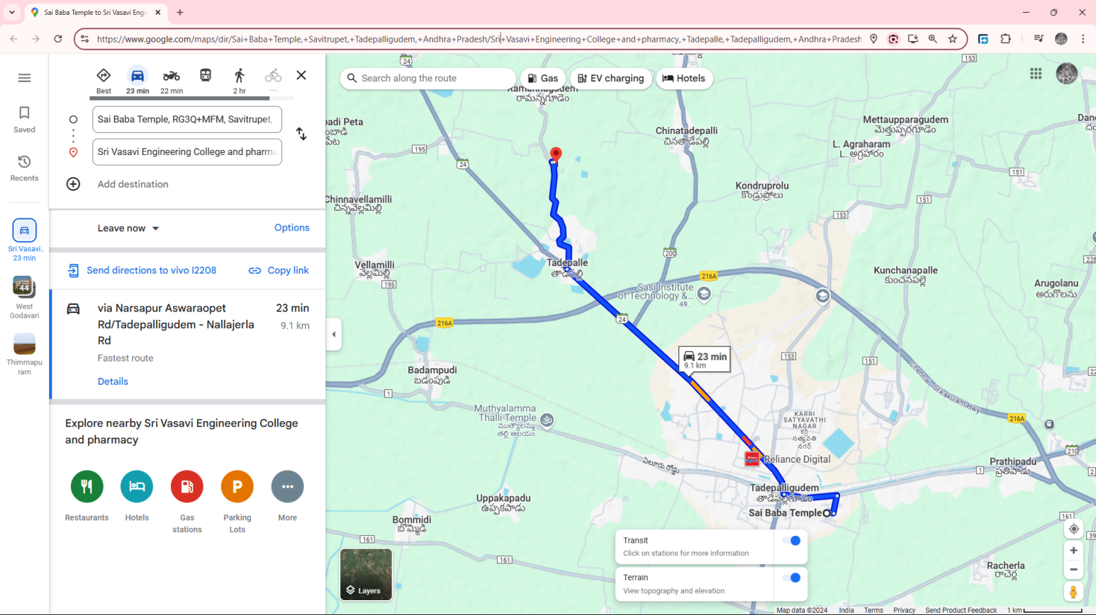
Bus No. 53 :
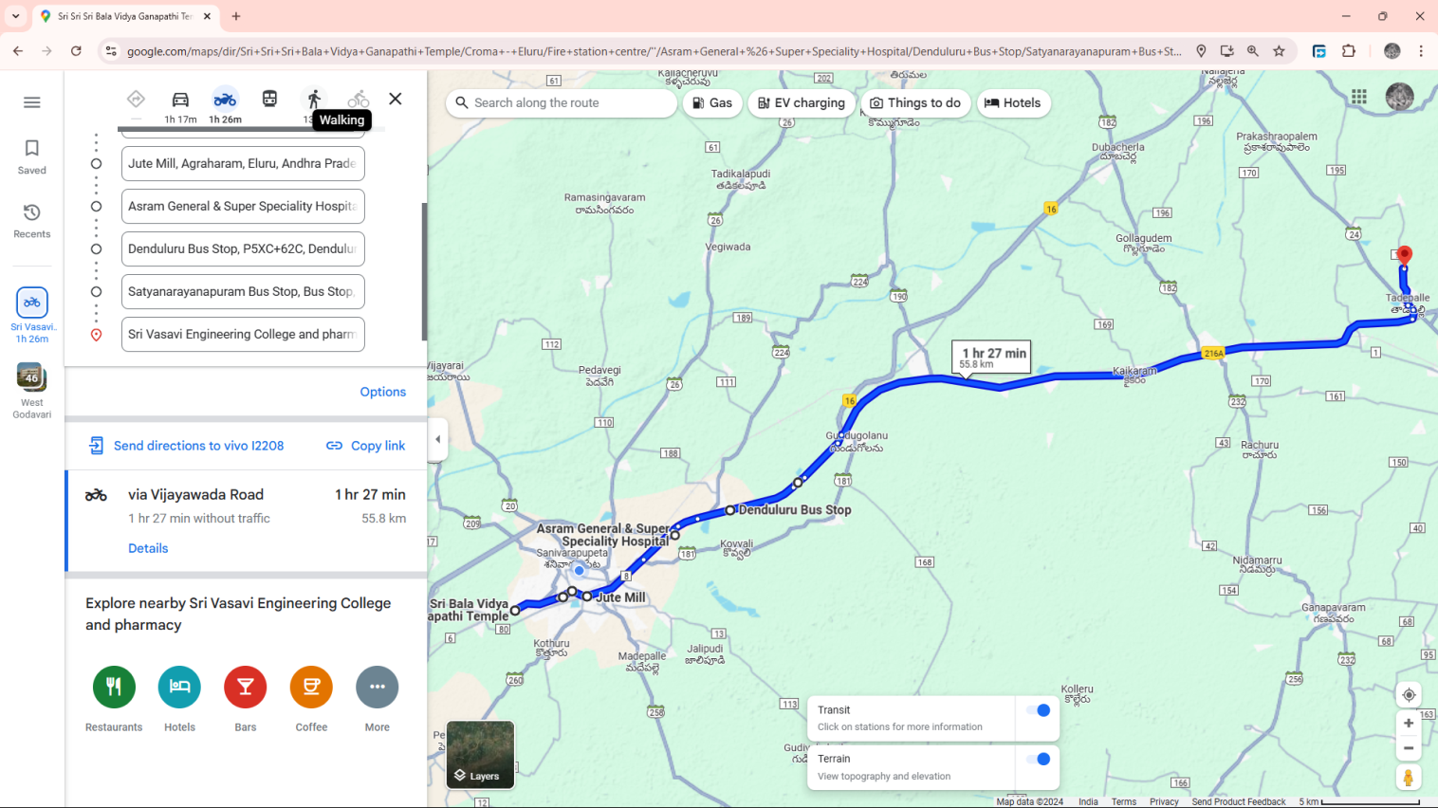

Conclusion:
The Explore Bus successfully provides a responsive, interactive application for real-time bus route and contact information. By combining Tkinter for interface development, Pillow for image handling, and Google Maps for route visualization, the application simplifies the process of obtaining bus-related details, enhancing accessibility for students, faculty, and community members. The program’s design allows for ease of use, and features such as suggestion-based search further improve the user experience. Future improvements may include shortest distance from the current location to the route, bus cancellations, bus replacements and time of arrival of bus to that particular stop. This project highlights the effective use of Python and Tkinter for creating practical, user-centric applications for transportation needs.

